Perera MTS

IT24101094

Lab8

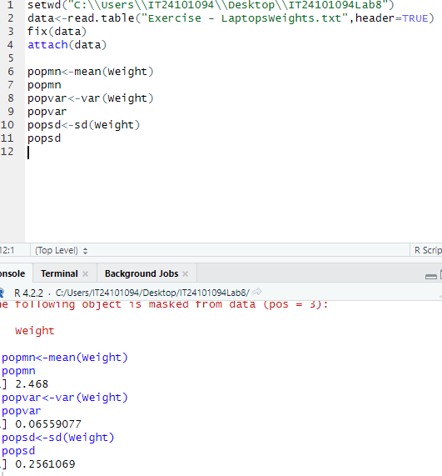1)

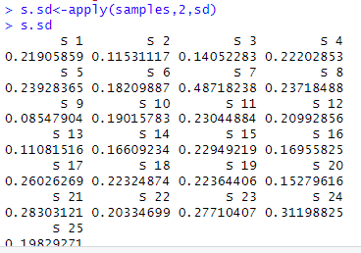

3) 